PLC Code Library [Cookbook]

Table of Contents

PLC Code Library

Mapping and calling of routines.

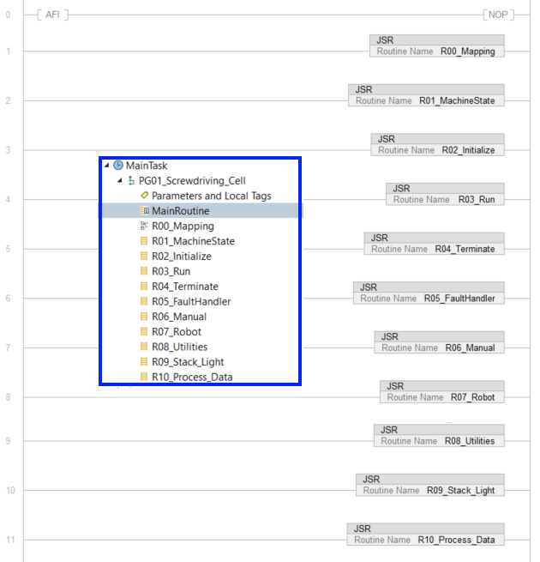

Mapping Examples

Notation: R1S1C0 Rack 1, Slot 1, Channel 0.
DCH( Instance, Input, Output);
DCH( R1S1C0_DCH, ECB1_RESET, Local:1:O.Pt00.Data);
DCH( R1S1C1_DCH, ECB2_RESET, Local:1:O.Pt01.Data);
DCH( R1S2C0_DCH, Local:2:I.Pt00.Data, ECB1_TRIP_INPUT);
DCH( R1S2C1_DCH, Local:2:I.Pt01.Data, ECB1_GRT80_INPUT);

COP(Source,Dest,Length);
COP(D14_IO_Link:I.Ch0Data[0],Festo_Analog_Buffer[0], 3); // Airflow (4-20mA)

Notes: Masked Move (MVM) instruction copies the Source to a Destination and allows portions of the data to be masked. The MVM instruction uses a Mask to pass or block Source data bits. A "1" in the mask means the data bit is passed; a "0" in the mask means the data bit is blocked. If integer data types are mixed, the instruction fills the upper bits of the smaller integer data types with 0s so that they are the same size as the largest data type.
The Copy File (COP) instruction copies the value(s) in the Source to the values in the Destination. The Source remains unchanged. Source: Initial element to copy, Dest: Initial element to be overwritten by the Source, Length: Number of Destination elements to copy. Important: Unexpected operation may occur if; Output tag operands are overwritten; Members of a structure operand are overwritten; Except when specified, structure operands are shared by multiple instructions.

DHC Add-On Instruction

DCH v1.0, Discrete Channel Controller. For use in mapping routines.

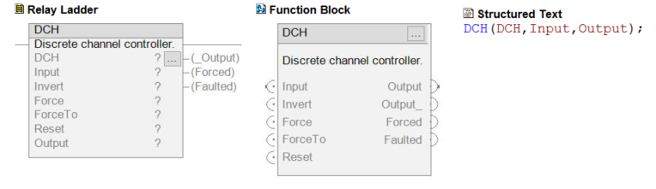
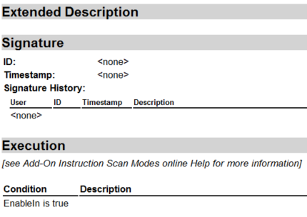
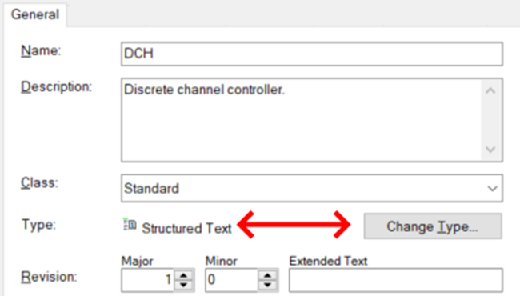

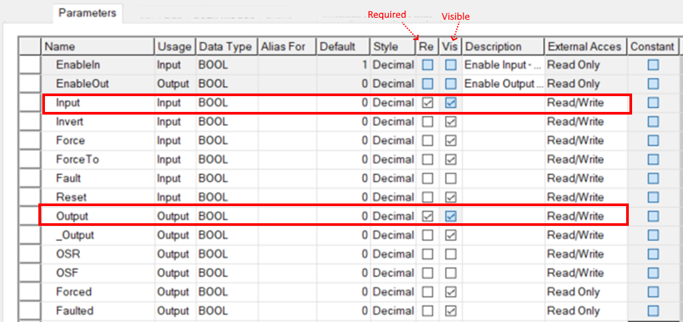

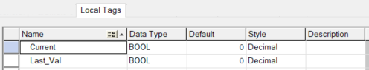

DHC function Logic:

// Grab the current status of the input.
Current := Input;
Forced := Force;

// Turn off both of the trigger bits.
OSR := 0;
OSF := 0;

// Check for the overwrite enable flag.
// If it's set ignore everything and just push the override value into the current.
if (Force) then
Current := ForceTo;
end_if;

// Write to the outputs now.
if (Invert)then
Output := not Current;
_Output := Current;
else
Output := Current;
_Output := not Current;
end_if;

// Check for triggers. If the value changes between the last evaluation and this one
// then we will set one of our trigger bits.
if (Last_Val xor Output) then
if (not Last_Val and Output) then
OSR := 1; // Low to high transition.
else
OSF := 1; // High to low transition.
end_if;
end_if;

// Capture the value of the input from this evaluation.
Last_Val := Current;

// Fault latching logic.
if Fault then
Faulted := 1;
end_if;

if Faulted and Reset then
Faulted := 0;
end_if;

Stack Light Add-On Instruction
RW Stack Light function block in ladder. Local Tags
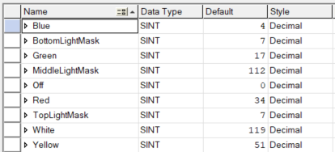
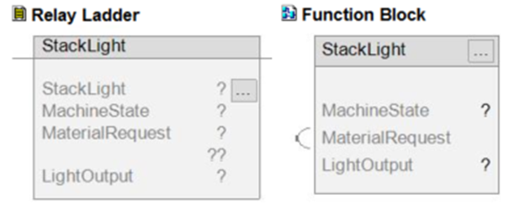
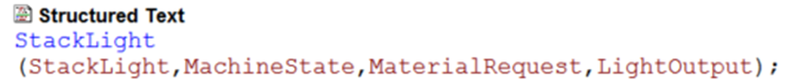
Parameters
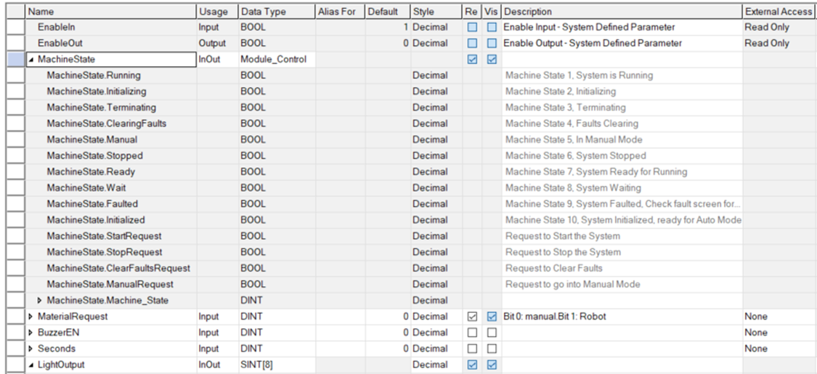
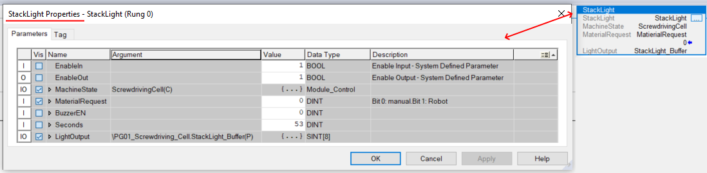
Stack Light Function Logic:
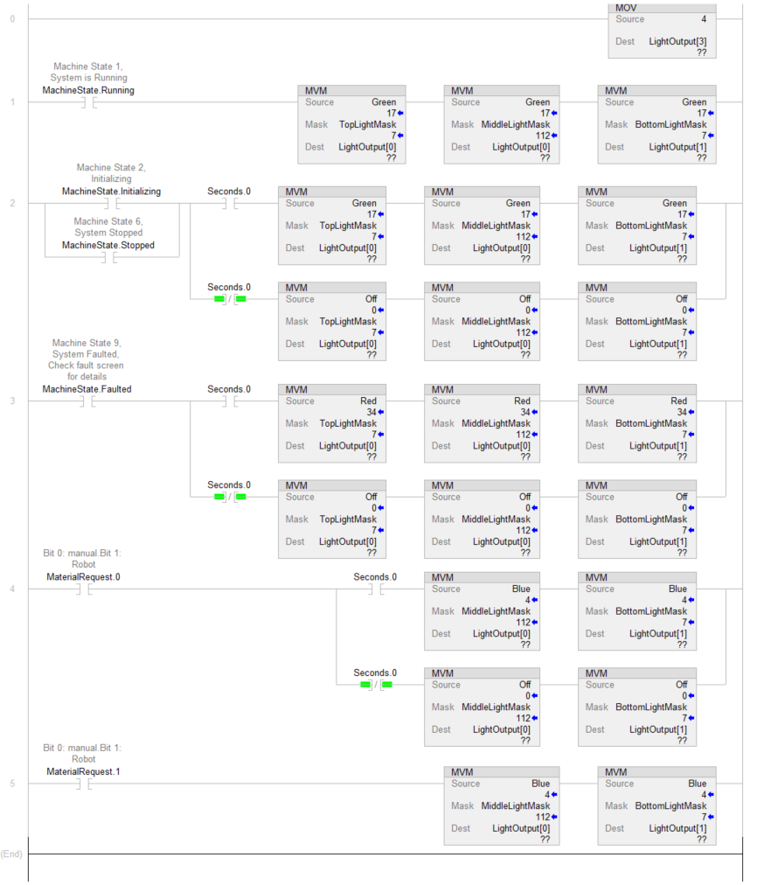

User Defined Data Type: DateTime

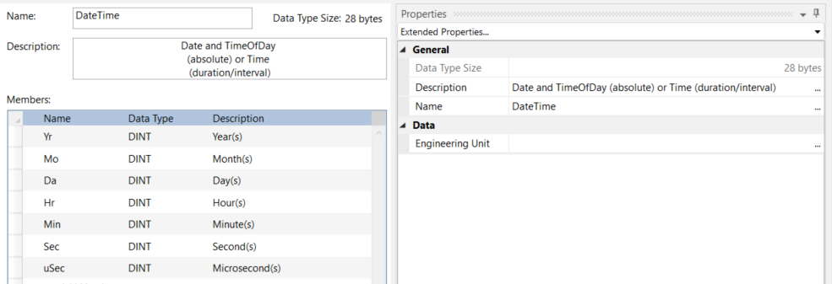

User Defined Data Type: RFID_Reader
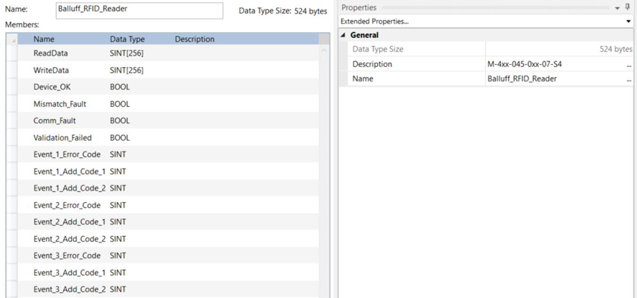

User Defined Data Type: Module_Control
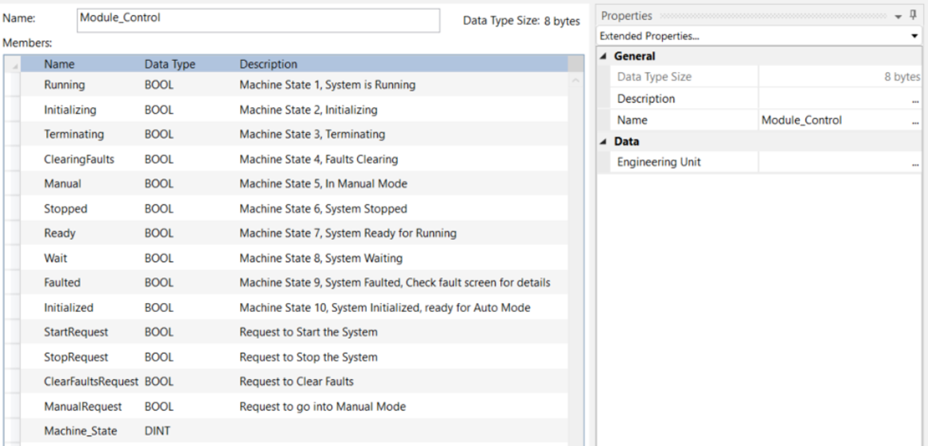

User Defined Data Type: Process_Data
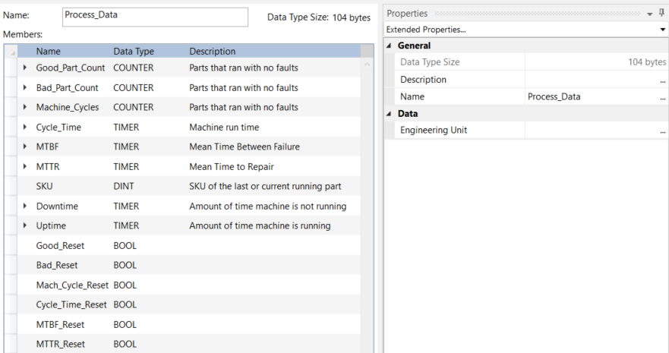

User Defined type: State_Control
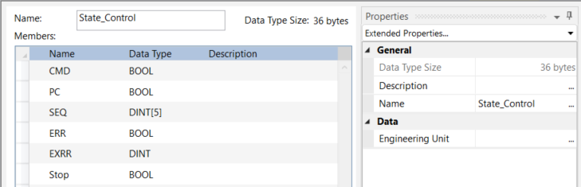

User Defined Type: Shift_Time
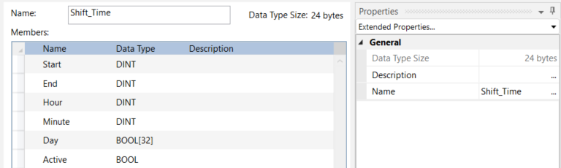

Add-on Instruction: AlarmHistory_AOI

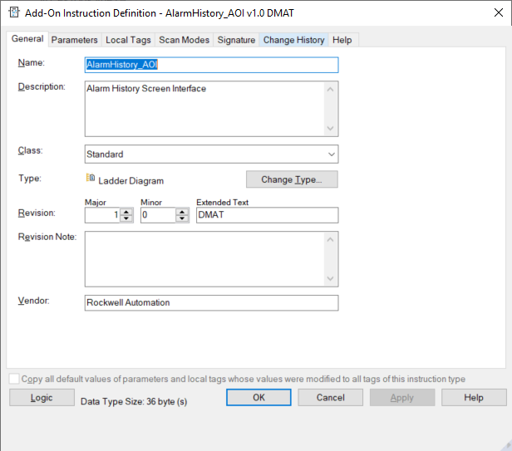

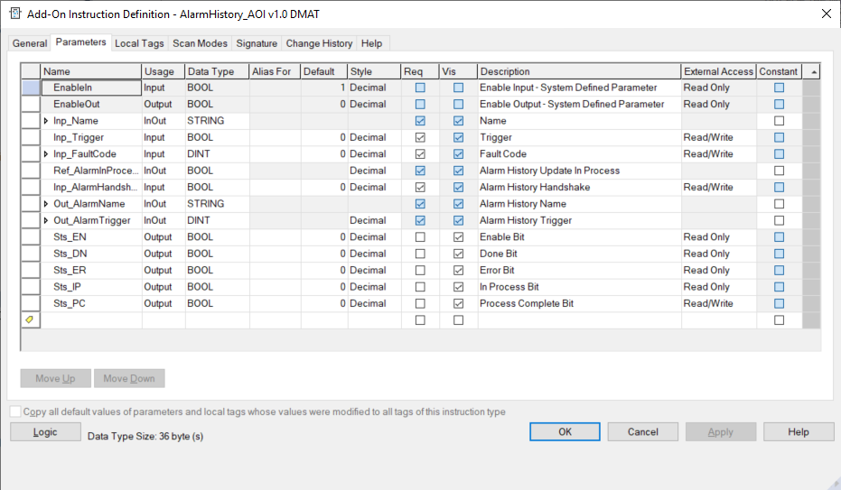
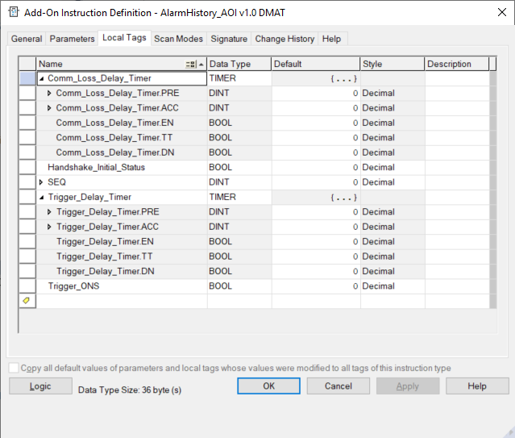
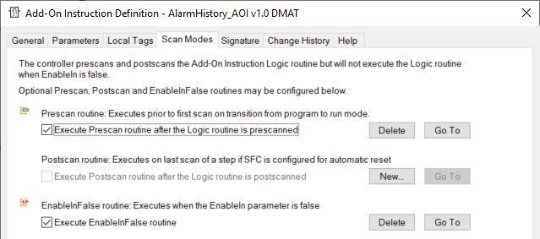
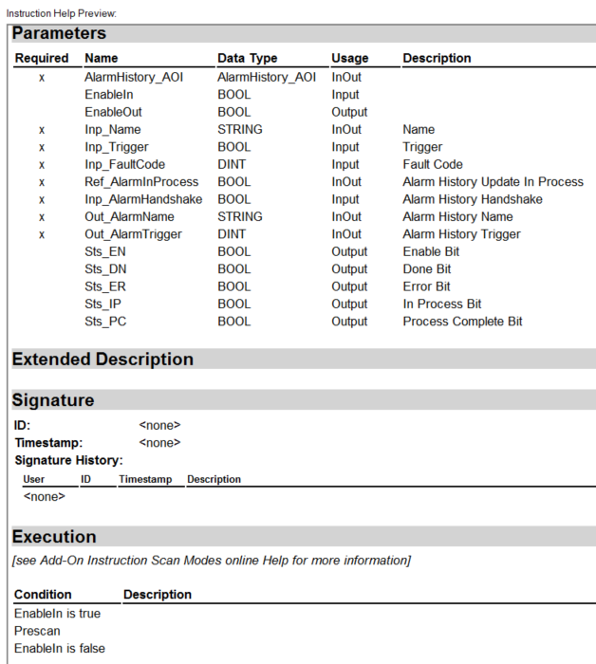

AlarmHistory_AOI v1.0 DMAT
Rockwell Automation
[Contact the Add-On Instruction developer for questions or problems with this instruction]
Alarm History Screen Interface
Class: Standard
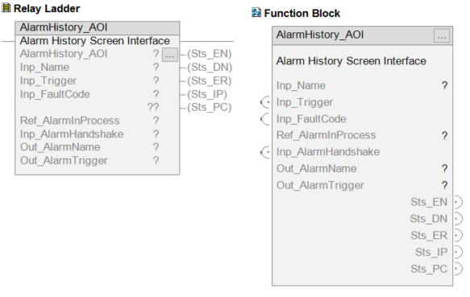

Structured Text
AlarmHistory_AOI(AlarmHistory_AOI,Inp_Name,Inp_Trigger,Inp_FaultCode,Ref_AlarmInProcess,Inp_AlarmHandshake,Out_AlarmName,Out_AlarmTrigger);

Logic
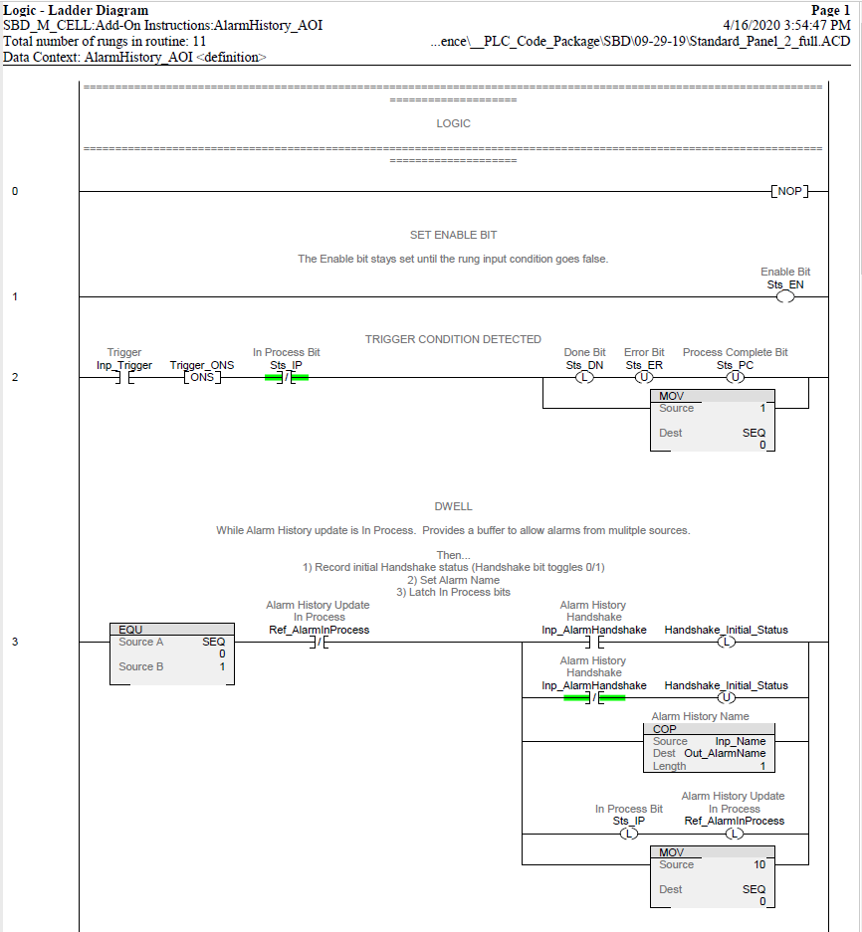
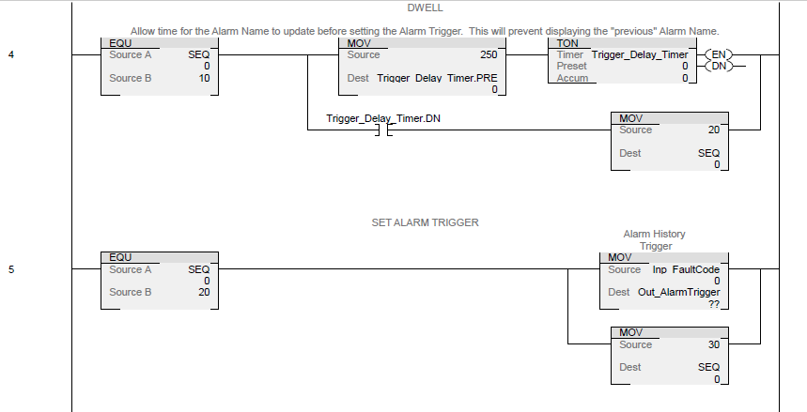

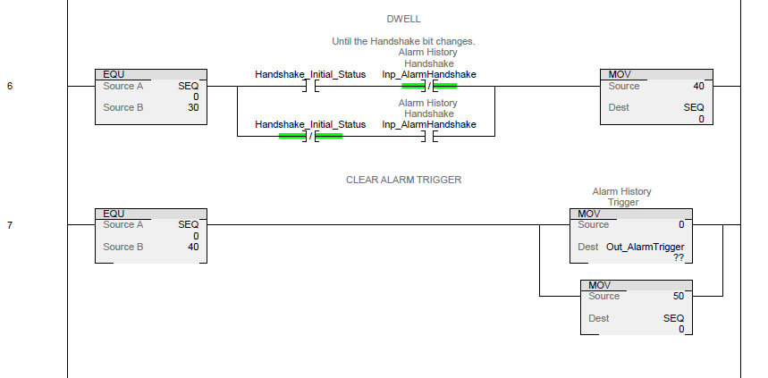
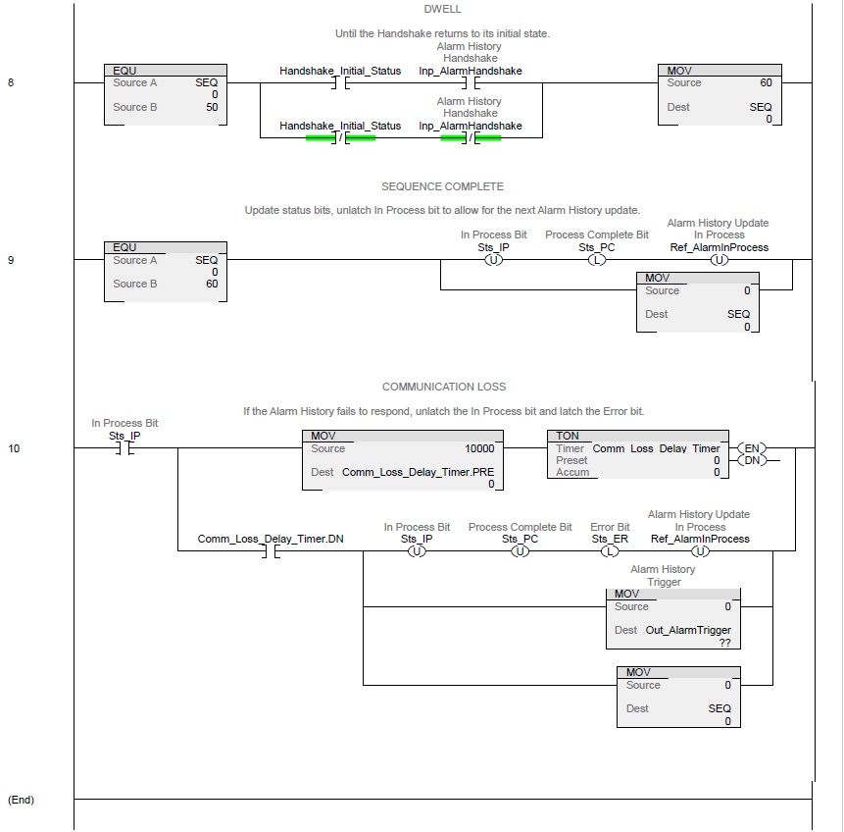

Add-on Instruction: T_ADD
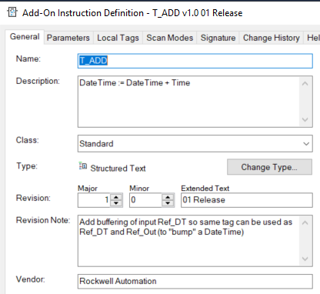

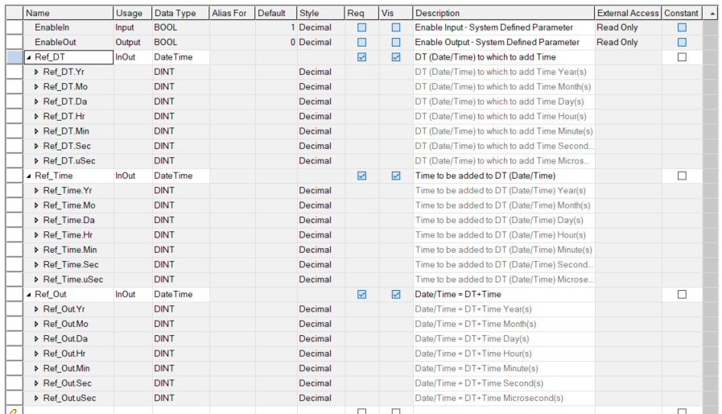
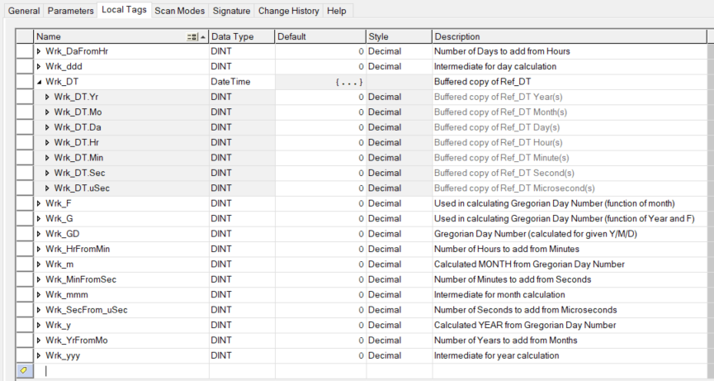

Extended Description Text:
T_Add : Add Date/Time plus Time to get new Date/Time

This instruction adds a given amount of Time to a Date/Time to arrive at a new Date/Time.
The new Date/Time is "normalized", that is, given as a valid (if possible) Gregorian Date and Time:

* 0 <= Microseconds < 1,000,000
* 0 <= Seconds < 60 (NOTE: this instruction cannot add leap seconds; sorry!)
* 0 <= Minutes < 60
* 0 <= Hours < 24
* 1 <= Day <= 31 AND Date is a Valid Gregorian Date (see below)
* 1 <= Month <= 12

NOTE: The Ref_DT parameter must be a valid Date and Time, NOT an AMOUNT of time!
The Ref_Time parameter is the AMOUNT of time! If you swap these, you'll get an invalid
result, at least if Ref_DT.Yr, Ref_DT.Mo or Ref_DT.Da is zero!

NOTE: This instruction does NOT switch to Julian dates for dates before 1582 (or 1753 or
whenever your place of interest switched to the Gregorian Calendar -- see Wikipedia on
"Gregorian Calendar" for details)! This instruction assumes the Gregorian Calendar extends
"indefinitely" (about 5.8 million years) either side of "zero" CE! It DOES handle the Gregorian
4 / 100 / 400 year rules, so Feb. 29, 2000 is a valid date, but Feb. 29, 2100 is not. It DOES
NOT handle Daylight Savings Time hour offsets when the amount of Time added carries the
Date/Time across summer/winter time boundaries.

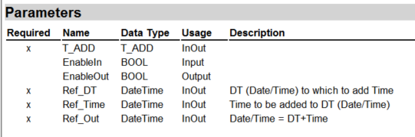

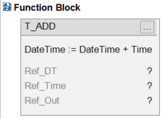
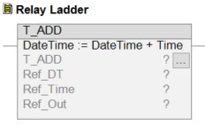

Structured Text
T_ADD(T_ADD,Ref_DT,Ref_Time,Ref_Out);

LOGIC

// T_ADD : TIME -- ADD DATE/TIME PLUS TIME -> DATE/TIME
//
// This instruction adds a given amount of Time to a Date/Time to arrive at a new Date/Time
// The new Date/Time is "normalized", that is, given as a valid (if possible) Gregorian Date and Time:
//
// * 0 <= Microseconds < 1,000,000
// * 0 <= Seconds < 60 (NOTE: this instruction cannot add leap seconds; sorry!
// * 0 <= Minutes < 60
// * 0 <= Hours < 24
// * 1 <= Day <= 31 AND Date is a Valid Gregorian Date (see below)
// * 1 <= Month <= 12
//
// NOTE: The Ref_DT parameter must be a valid Date and Time, NOT an AMOUNT of time! The Ref_Time parameter is the AMOUNT of
// time! If you swap these, you'll get an invalid result, at least if Ref_DT.Yr, Ref_DT.Mo or Ref_DT.Da is zero!
//
// NOTE: This instruction does NOT switch to Julian dates for dates before 1582 (or 1753 or whenever your place of interest
// switched to the Gregorian Calendar -- see Wikipedia on "Gregorian Calendar" for details)! This instruction assumes the
// Gregorian Calendar extends "indefinitely" (about 5.8 million years) either side of "zero" CE! It DOES handle the
// Gregorian 4 / 100 / 400 year rules, so Feb. 29, 2000 is a valid date, but Feb. 29, 2100 is not. It DOES NOT handle
// Daylight Savings Time hour offsets when the amount of Time added carries the Date/Time across summer/winter time boundaries.
//
// NOTE: For algorithms used for Gregorian Date and Days Between Dates, see http://alcor.concordia.ca/~gpkatch/gdate-algorithm.html
//
// V1.0-00 2009-04-23: Initial formal release
// V1.0-01 2014-02-28: Add buffering of input Ref_DT so same tag can be used as Ref_DT and Ref_Out (to "bump" a DateTime)
//

// Buffer input DateTime
Wrk_DT.Yr := Ref_DT.Yr;
Wrk_DT.Mo := Ref_DT.Mo;
Wrk_DT.Da := Ref_DT.Da;
Wrk_DT.Hr := Ref_DT.Hr;
Wrk_DT.Min := Ref_DT.Min;
Wrk_DT.Sec := Ref_DT.Sec;
Wrk_DT.uSec := Ref_DT.uSec;

// Add Microseconds (accounting for adding a negative number of Microseconds!)
Ref_Out.uSec := (Wrk_DT.uSec+Ref_Time.uSec) MOD 1000000;
// Carry excess Seconds
Wrk_SecFrom_uSec := (Wrk_DT.uSec+Ref_Time.uSec) / 1000000;
IF (Ref_Out.uSec < 0) THEN
Ref_Out.uSec := Ref_Out.uSec + 1000000;
Wrk_SecFrom_uSec := Wrk_SecFrom_uSec - 1;
END_IF;

// Add Seconds
Ref_Out.Sec := (Wrk_DT.Sec+Ref_Time.Sec+Wrk_SecFrom_uSec) MOD 60;
// Carry excess Minutes
Wrk_MinFromSec := (Wrk_DT.Sec+Ref_Time.Sec+Wrk_SecFrom_uSec) / 60;
// Handle negative sum
IF (Ref_Out.Sec < 0) THEN
Ref_Out.Sec := Ref_Out.Sec + 60;
Wrk_MinFromSec := Wrk_MinFromSec - 1;
END_IF;

// Add Minutes
Ref_Out.Min := (Wrk_DT.Min+Ref_Time.Min+Wrk_MinFromSec) MOD 60;
// Carry excess Hours
Wrk_HrFromMin := (Wrk_DT.Min+Ref_Time.Min+Wrk_MinFromSec) / 60;
// Handle negative sum
IF (Ref_Out.Min < 0) THEN
Ref_Out.Min := Ref_Out.Min + 60;
Wrk_HrFromMin := Wrk_HrFromMin - 1;
END_IF;

// Add Hours
Ref_Out.Hr := (Wrk_DT.Hr+Ref_Time.Hr+Wrk_HrFromMin) MOD 24;
// Carry excess Days
Wrk_DaFromHr := (Wrk_DT.Hr+Ref_Time.Hr+Wrk_HrFromMin) / 24;
// Handle negative sum
IF (Ref_Out.Hr < 0) THEN
Ref_Out.Hr := Ref_Out.Hr + 24;
Wrk_DaFromHr := Wrk_DaFromHr - 1;
END_IF;

// That takes care of the time. To add the days, we need to compute a Gregorian Day Number from the input Date,
// then add the days and compute a Date from the new total Gregorian Day Number. This takes care of the days in the months.
// (After thet, we'll add the Months and Years like we did with the time.)

// Compute the Gregorian Day Number for the input Date
Wrk_F := (Wrk_DT.Mo+9) MOD 12;
Wrk_G := Wrk_DT.Yr - Wrk_F/10;
Wrk_GD := 365*Wrk_G+Wrk_G/4-Wrk_G/100+Wrk_G/400+(Wrk_F*306+5)/10+Wrk_DT.Da-1;

// Add the days
Wrk_GD := Wrk_GD+Ref_Time.Da+Wrk_DaFromHr;

// And back out from this Gregorian Day Number to a date
Wrk_yyy := TRUNC (Wrk_GD +1.5)/365.2425;
Wrk_ddd := Wrk_GD - (365*Wrk_yyy+Wrk_yyy/4-Wrk_yyy/100+Wrk_yyy/400);
IF (Wrk_ddd < 0) THEN
Wrk_yyy := Wrk_yyy - 1;
Wrk_ddd := Wrk_GD - (365*Wrk_yyy+Wrk_yyy/4-Wrk_yyy/100+Wrk_yyy/400);
IF (Wrk_ddd < 0) THEN
Wrk_yyy := Wrk_yyy - 1;
Wrk_ddd := Wrk_GD - (365*Wrk_yyy+Wrk_yyy/4-Wrk_yyy/100+Wrk_yyy/400);
END_IF;
END_IF;
Wrk_mmm := (100*Wrk_ddd + 52)/3060;
Wrk_y := Wrk_yyy + (Wrk_mmm + 2)/12;
Wrk_m := ((Wrk_mmm + 2) MOD 12) + 1;
Ref_Out.Da := Wrk_ddd - ((Wrk_mmm * 306) + 5)/10 + 1;

// Add Months
Ref_Out.Mo := ((Wrk_m+Ref_Time.Mo-1) MOD 12)+1;
// Carry excess Years
Wrk_YrFromMo := (Wrk_m+Ref_Time.Mo-1) / 12;
// Handle negative sum
IF (Ref_Out.Mo < 1) THEN
Ref_Out.Mo := Ref_Out.Mo + 12;
Wrk_YrFromMo := Wrk_YrFromMo - 1;
END_IF;

// Add Years
Ref_Out.Yr := Wrk_y+Ref_Time.Yr+Wrk_YrFromMo;

Add-on Instrcution: T_DST
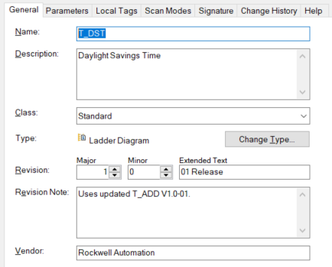

Parameters
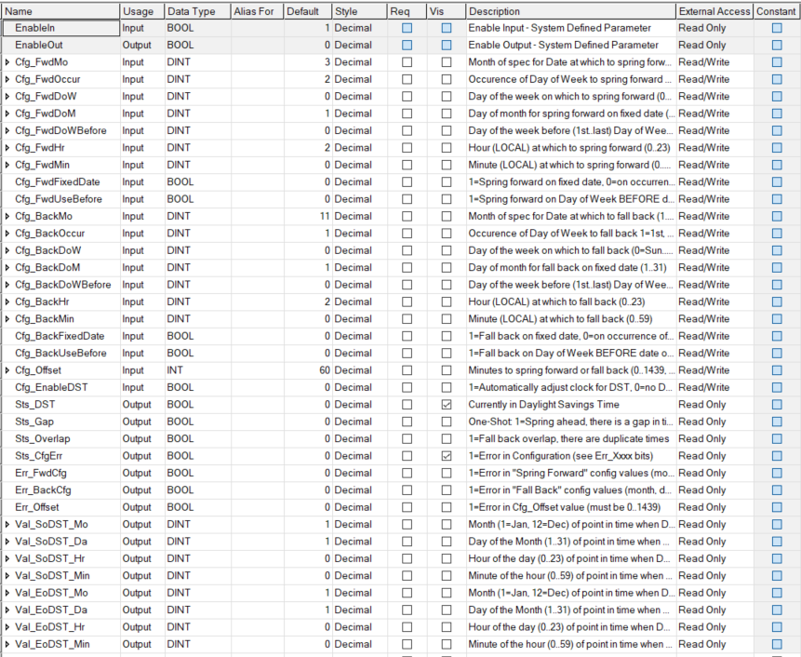

Local Tags
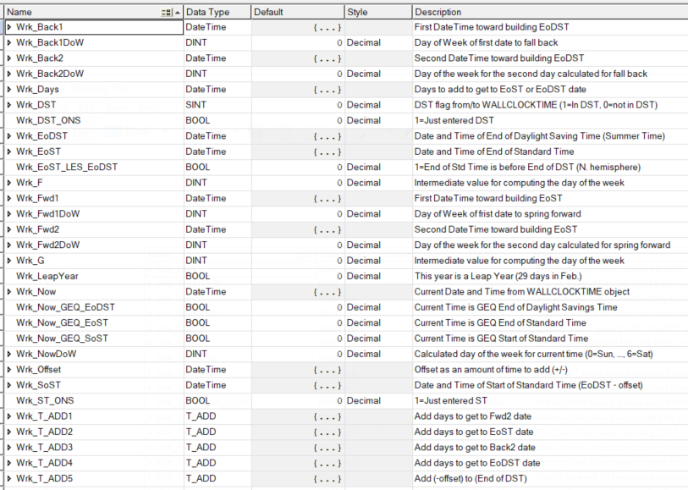

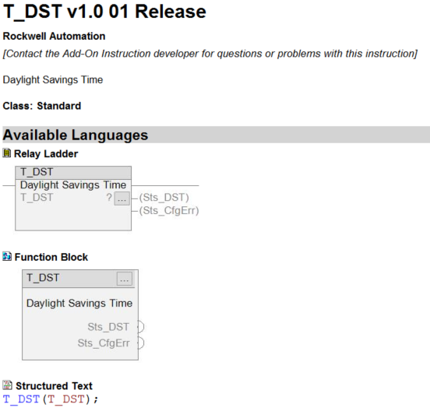

Parameters
Required | Name | Data Type | Usage | Description
x | T_DST | T_DST | InOut
 | EnableIn | BOOL | Input
 | EnableOut | BOOL | Output
 | Cfg_FwdMo | DINT | Input | Month of spec for Date at which to spring forward (1..12)
 | Cfg_FwdOccur | DINT | Input | Occurence of Day of Week to spring forward 1=1st, 2=2nd, .. 5=last
 | Cfg_FwdDoW | DINT | Input | Day of the week on which to spring forward (0=Sun..6=Sat)
 | Cfg_FwdDoM | DINT | Input | Day of month for spring forward on fixed date (1..31)
 | Cfg_FwdDoWBefore | DINT | Input | Day of the week before (1st..last) Day of Week or Date (0=Sun..6=Sat)
 | Cfg_FwdHr | DINT | Input | Hour (LOCAL) at which to spring forward (0..23)
 | Cfg_FwdMin | DINT | Input | Minute (LOCAL) at which to spring forward (0..59)
 | Cfg_FwdFixedDate | BOOL | Input | 1=Spring forward on fixed date, 0=on occurrence of DoW
 | Cfg_FwdUseBefore | BOOL | Input | 1=Spring forward on Day of Week BEFORE date or day of week
 | Cfg_BackMo | DINT | Input | Month of spec for Date at which to fall back (1..12)
 | Cfg_BackOccur | DINT | Input | Occurence of Day of Week to fall back 1=1st, 2=2nd, ... 5=last
 | Cfg_BackDoW | DINT | Input | Day of the week on which to fall back (0=Sun..6=Sat)
 | Cfg_BackDoM | DINT | Input | Day of month for fall back on fixed date (1..31)
 | Cfg_BackDoWBefore | DINT | Input | Day of the week before (1st..last) Day of Week or Date (0=Sun..6=Sat)
 | Cfg_BackHr | DINT | Input | Hour (LOCAL) at which to fall back (0..23)
 | Cfg_BackMin | DINT | Input | Minute (LOCAL) at which to fall back (0..59)
 | Cfg_BackFixedDate | BOOL | Input | 1=Fall back on fixed date, 0=on occurrence of DoW
 | Cfg_BackUseBefore | BOOL | Input | 1=Fall back on Day of Week BEFORE date or day of week
 | Cfg_Offset | INT | Input | Minutes to spring forward or fall back (0..1439, def=60)
 | Cfg_EnableDST | BOOL | Input | 1=Automatically adjust clock for DST, 0=no DST, clear "ApplyDST" always
 | Sts_DST | BOOL | Output | Currently in Daylight Savings Time
 | Sts_Gap | BOOL | Output | One-Shot: 1=Spring ahead, there is a gap in times
 | Sts_Overlap | BOOL | Output | 1=Fall back overlap, there are duplicate times
 | Sts_CfgErr | BOOL | Output | 1=Error in Configuration (see Err_Xxxx bits)
 | Err_FwdCfg | BOOL | Output | 1=Error in "Spring Forward" config values (month, date, DoW, hr, min)
 | Err_BackCfg | BOOL | Output | 1=Error in "Fall Back" config values (month, date, DoW, hr, min)
 | Err_Offset | BOOL | Output | 1=Error in Cfg_Offset value (must be 0..1439)
 | Val_SoDST_Mo | DINT | Output | Month (1=Jan, 12=Dec) of point in time when DST starts
 | Val_SoDST_Da | DINT | Output | Day of the Month (1..31) of point in time when DST starts
 | Val_SoDST_Hr | DINT | Output | Hour of the day (0..23) of point in time when DST starts
 | Val_SoDST_Min | DINT | Output | Minute of the hour (0..59) of point in time when DST starts
 | Val_EoDST_Mo | DINT | Output | Month (1=Jan, 12=Dec) of point in time when DST ends
 | Val_EoDST_Da | DINT | Output | Day of the Month (1..31) of point in time when DST ends
 | Val_EoDST_Hr | DINT | Output | Hour of the day (0..23) of point in time when DST ends
 | Val_EoDST_Min | DINT | Output | Minute of the hour (0..59) of point in time when DST ends

Extended Description
This instruction manages Daylight Saving Time. It uses a number of configuration
values to allow handling a wide variety of national and regional rules for
when to start and end Daylight Saving Time (or "Summer Time").
For use with HMI, it also provides Values for display of the Month/Day
and Hour:Minute of the points in time when DST starts and ends.
Plus, for logging logic, it provides bits to indicate when timestamps might
have an Overlap (1:30 a.m. happens twice) or there is a Gap (one-shot).
For best results:
1. Clear Cfg_EnableDST to 0.
2. Open the Controller Properties, clear the DST checkbox
and set the clock to local STANDARD time
3. Configure the T_DST instruction per the instructions below.
4. Set the Cfg_EnableDST bit to 1.
The clock will be switched to DST based on the rules entered
if DST is currently in effect for your location.
Configuration:
------------------------------
Cfg_FwdMo: Month specified in rule for Date at which to spring forward (1..12)
Cfg_FwdOccur: Occurence of Day of Week to spring forward 1=1st, 2=2nd, .. 5=last
Cfg_FwdDoW: Day of the week on which to spring forward (0=Sun..6=Sat)
Cfg_FwdDoM: Day of month for spring forward if on a fixed date (1..31)
Cfg_FwdDoWBefore: Day of the week BEFORE the 1st..last Day of Week or Date (0=Sun..6=Sat)
Cfg_FwdHr: Hour (LOCAL) at which to spring forward (0..23)
Cfg_FwdMin: Minute (LOCAL) at which to spring forward (0..59)
Cfg_FwdFixedDate: 1=Spring forward on fixed date, 0=on occurrence of Day of Week
Cfg_FwdUseBefore: 1=Spring forward on Day of Week BEFORE date or day of week
Cfg_BackMo: Month specified in rule for Date at which to fall back (1..12)
Cfg_BackOccur: Occurence of Day of Week to fall back 1=1st, 2=2nd, .. 5=last
Cfg_BackDoW: Day of the week on which to fall bacj (0=Sun..6=Sat)
Cfg_BackDoM: Day of month for fall back if on a fixed date (1..31)
Cfg_BackDoWBefore: Day of the week BEFORE the 1st..last Day of Week or Date (0=Sun..6=Sat)
Cfg_BackHr: Hour (LOCAL) at which to fall back (0..23)
Cfg_BackMin: Minute (LOCAL) at which to fall back (0..59)
Cfg_BackFixedDate: 1=Fall back on fixed date, 0=on occurrence of Day of Week
Cfg_BackUseBefore: 1=Fall back on Day of Week BEFORE date or day of week
Cfg_Offset: Number of minutes to spring forward or fall back (0..1439, def=60)
Cfg_EnableDST: 1=Automatically adjust clock for DST, 0=Always Standard Time, no DST

Execution
[see Add-On Instruction Scan Modes online Help for more information]
Condition | Description
EnableIn is true | Manage Standard Time and Daylight Saving Time ("summer time") based on rules

Revision v1.0 Notes
Uses updated T_ADD V1.0-01.

Various Ladder Examples

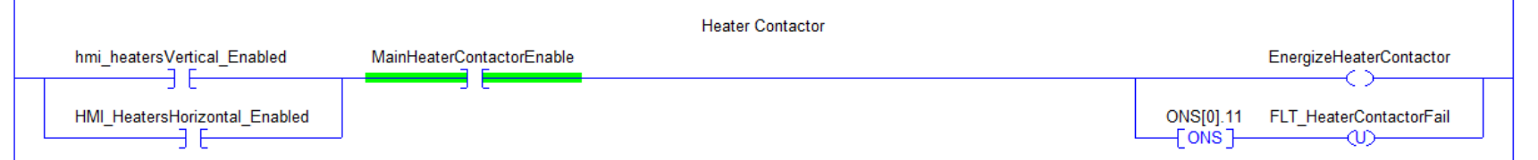

Add-on Instruction w/ logic for heater control

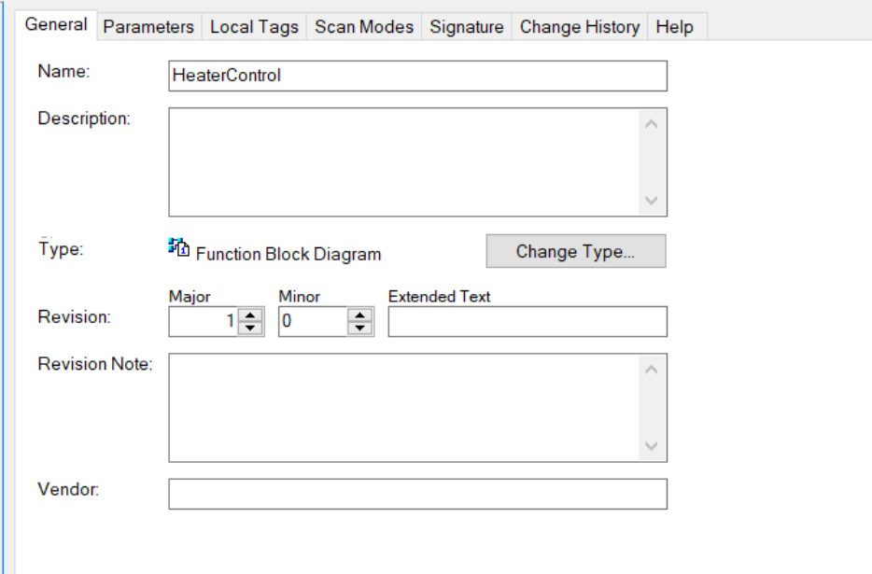

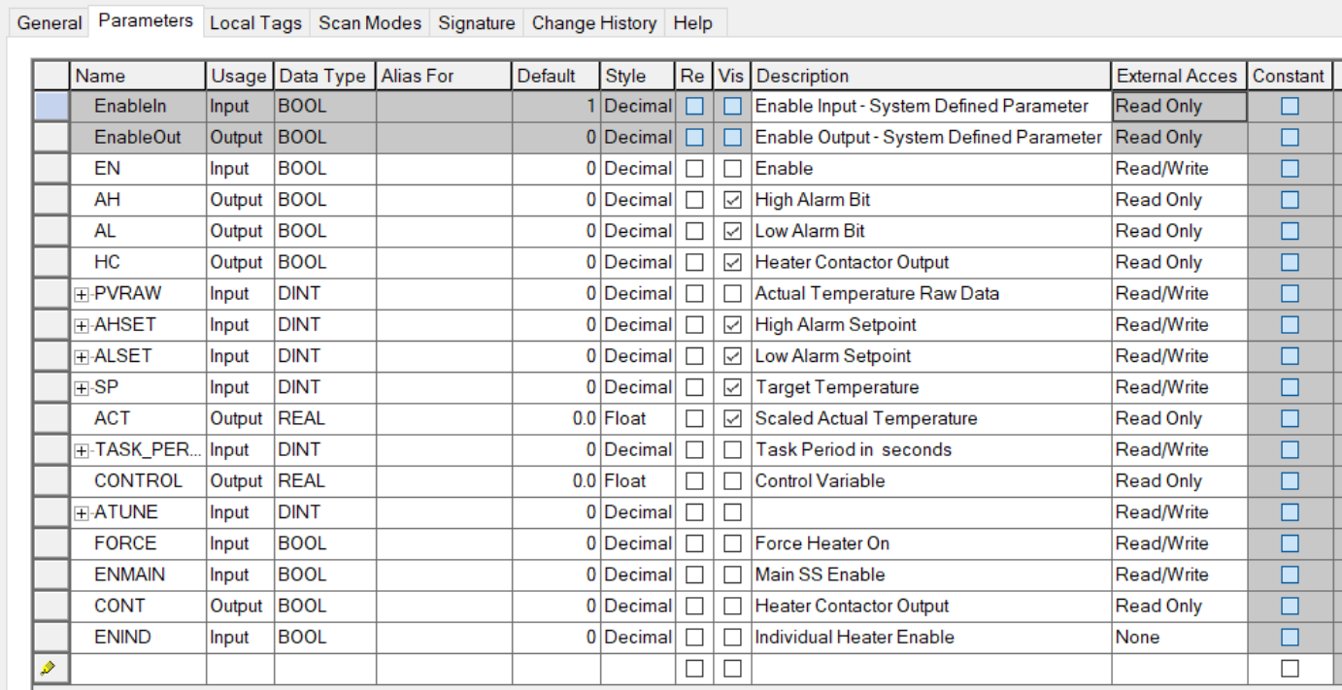

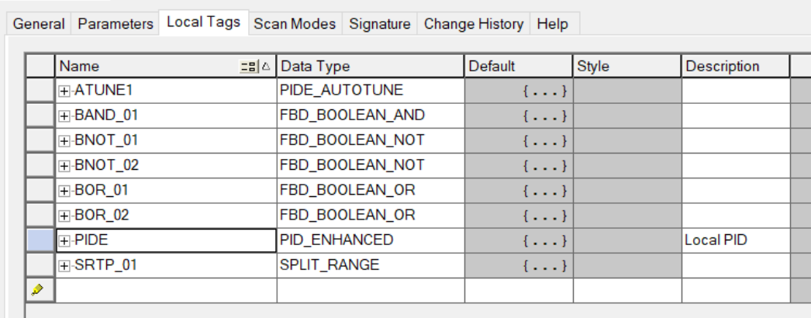

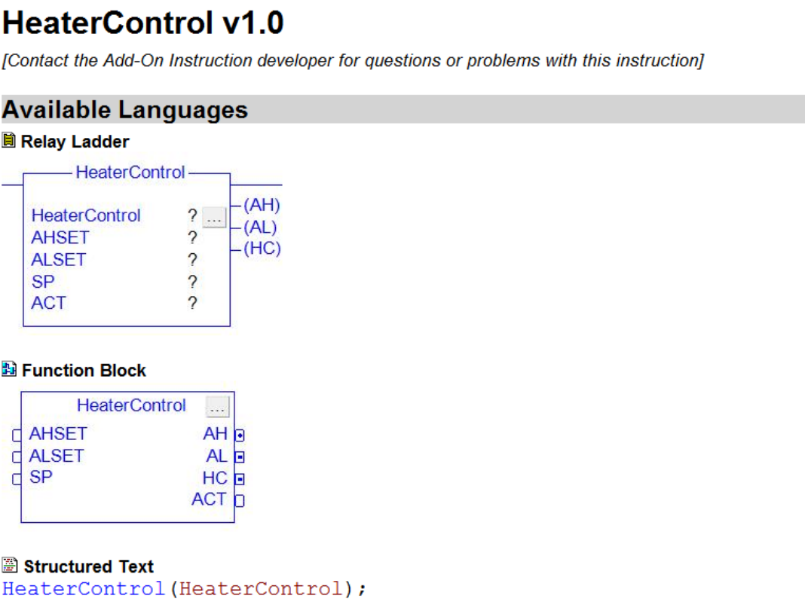

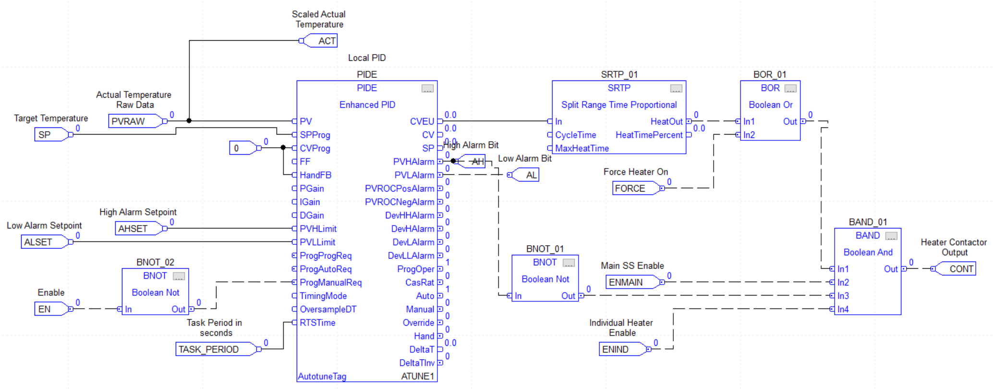

Manipulate Alarms

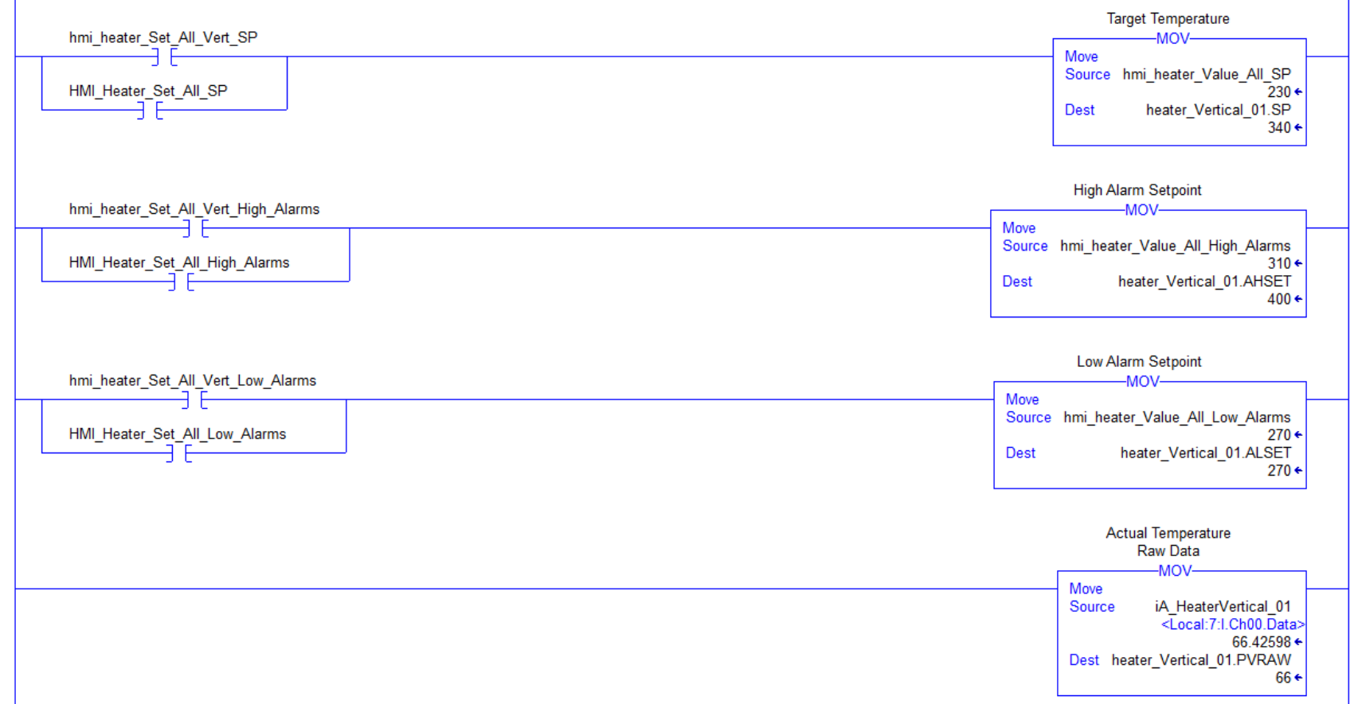

One Shot Rising

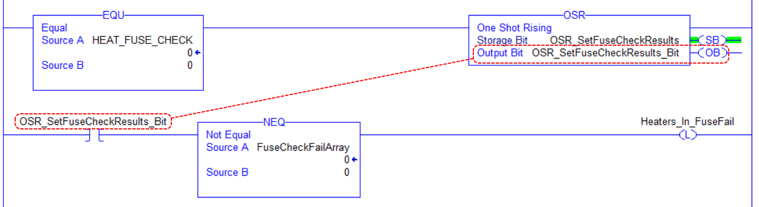

OSR instruction sets the output bit for one scan when rung-condition-in transitions from false to true.
Storage bit: Internal storage bit, stores the rung-condition-in from the last time the inst. was executed.
Output bit: Bit to be modified.

Establishing Safety Interlocks

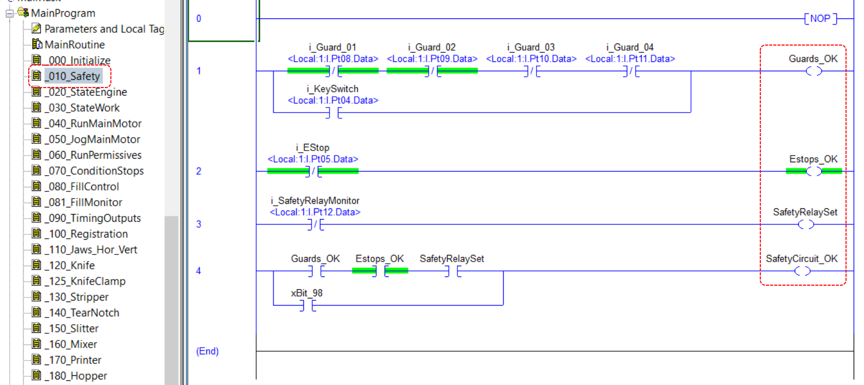

Initializing Axis

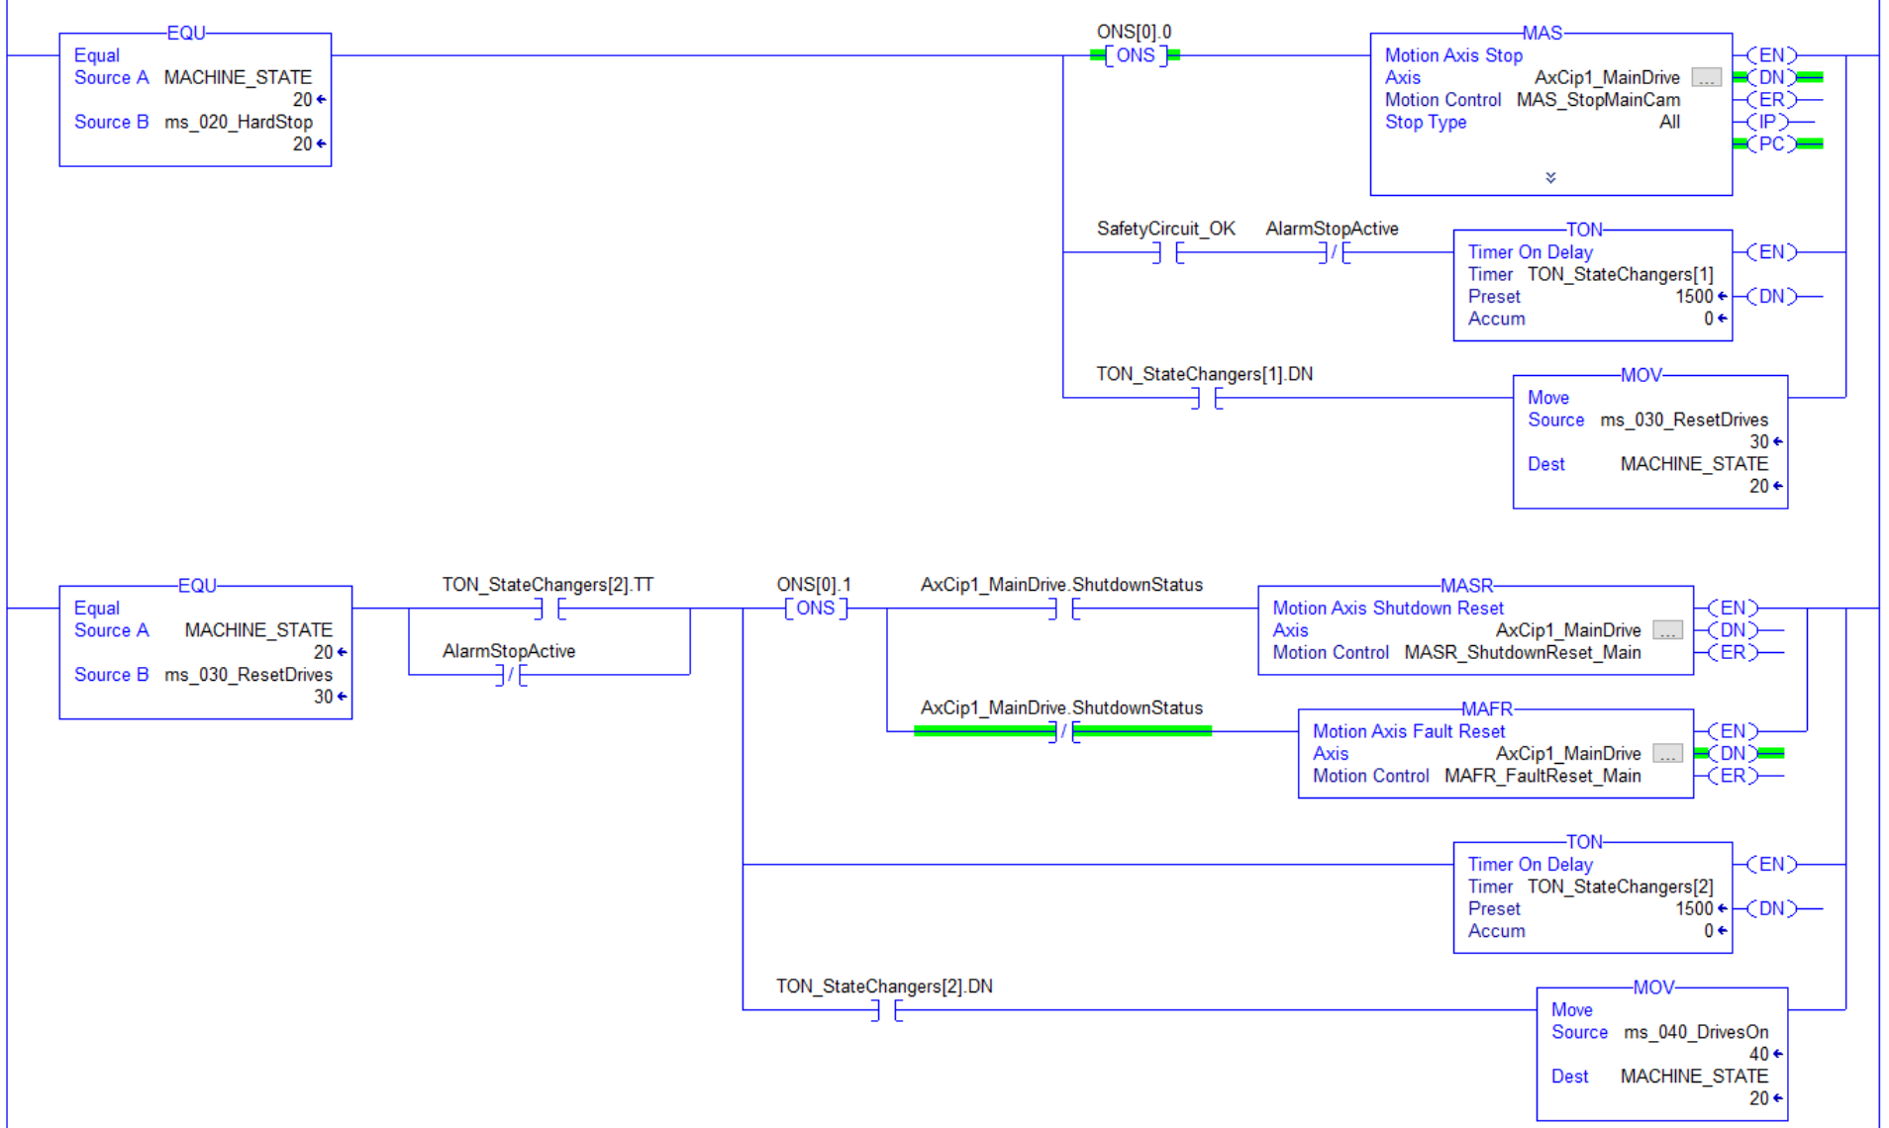

Homing Sequence Example

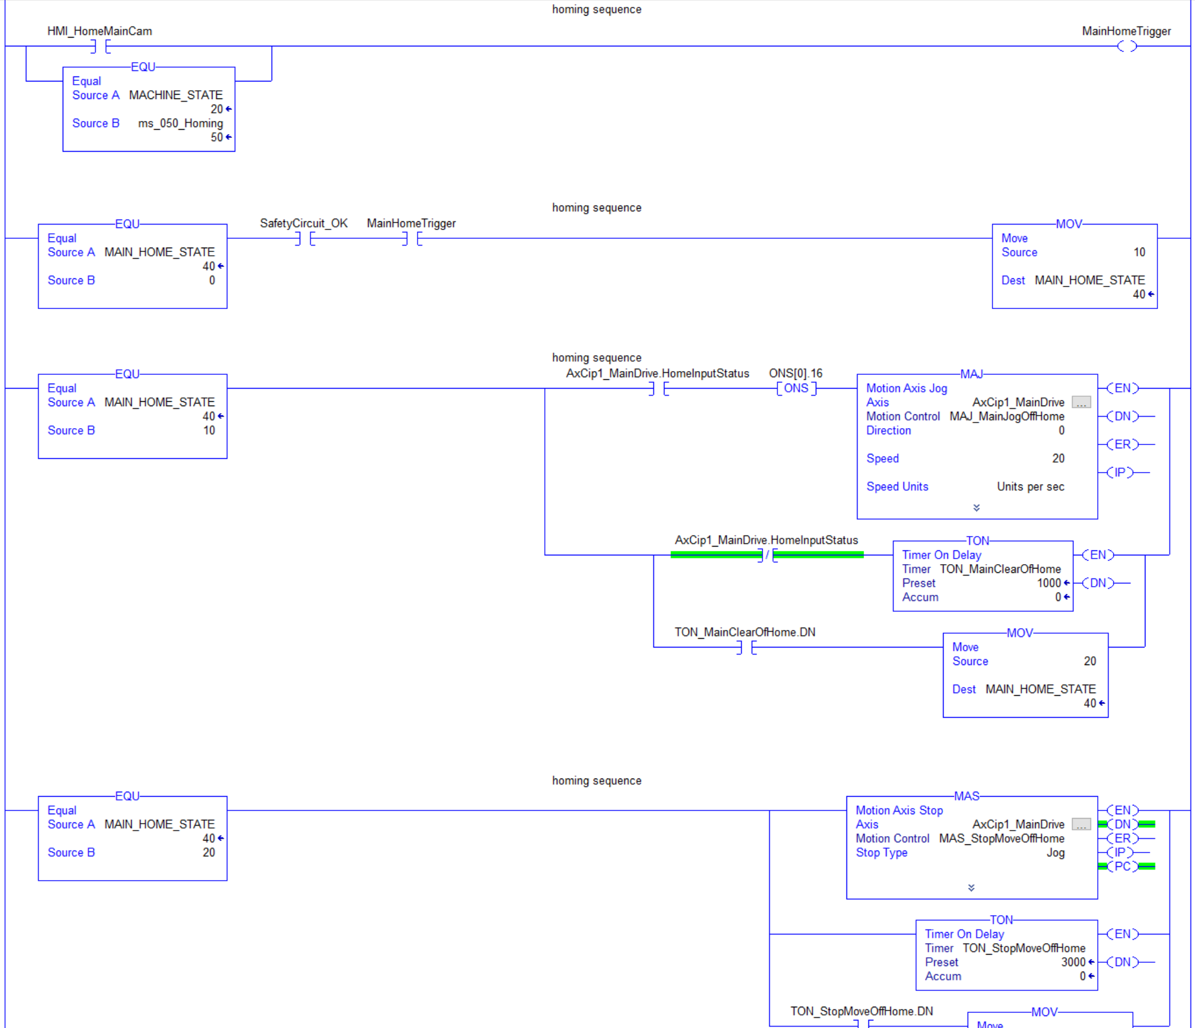

Use Limit to Select Action

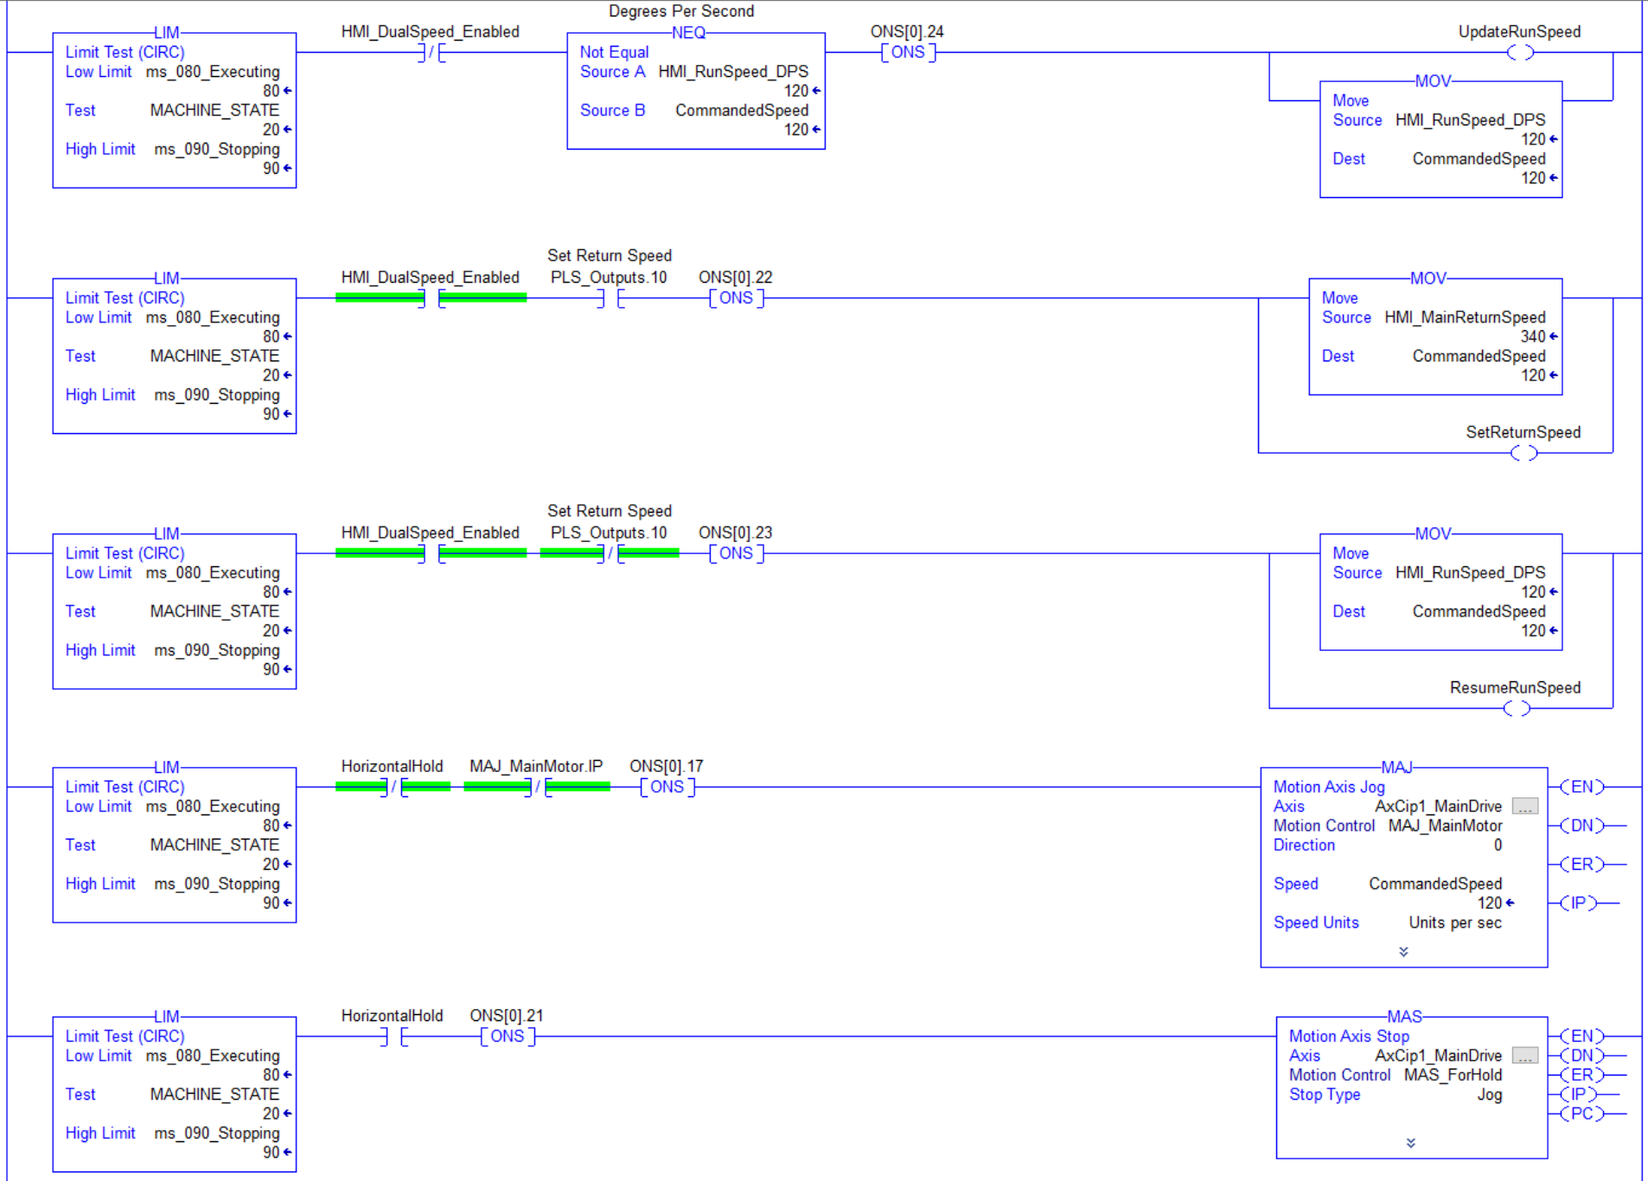

Jog Example

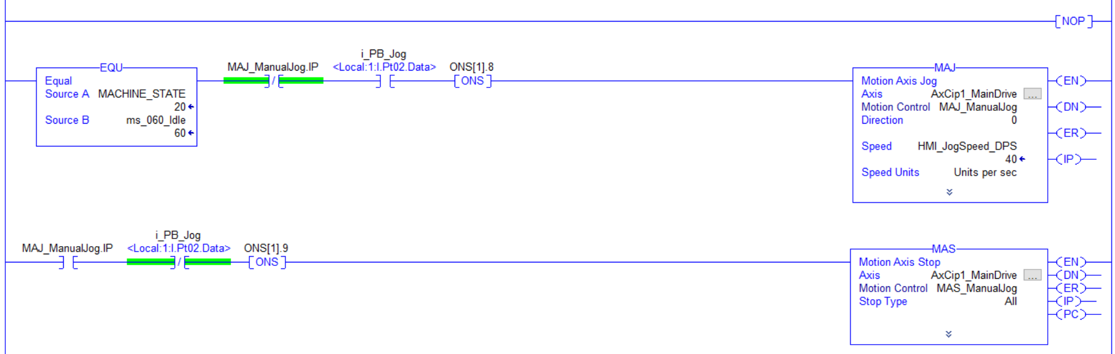

Set Array Elements with Solenoid

Limit, One Shot, and Counter

Reset Function

The RES instruction resets a TIMER, COUNTER, or CONTROL structure.

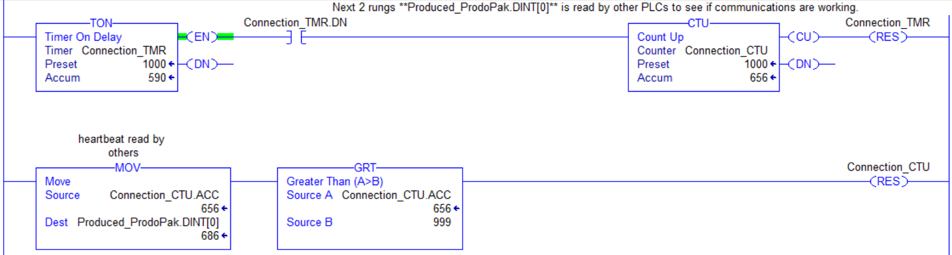

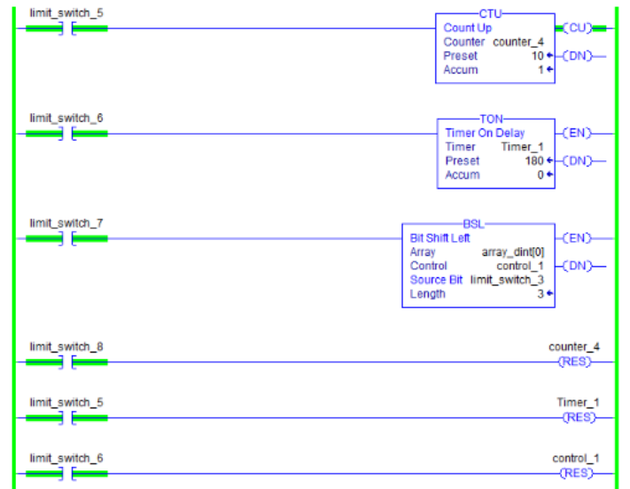

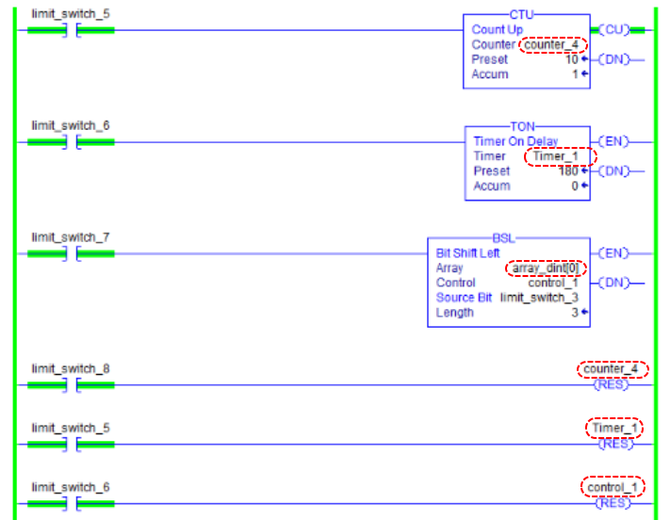

Flash Master AOI

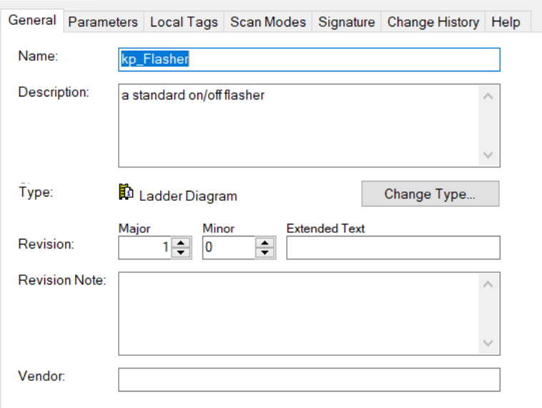

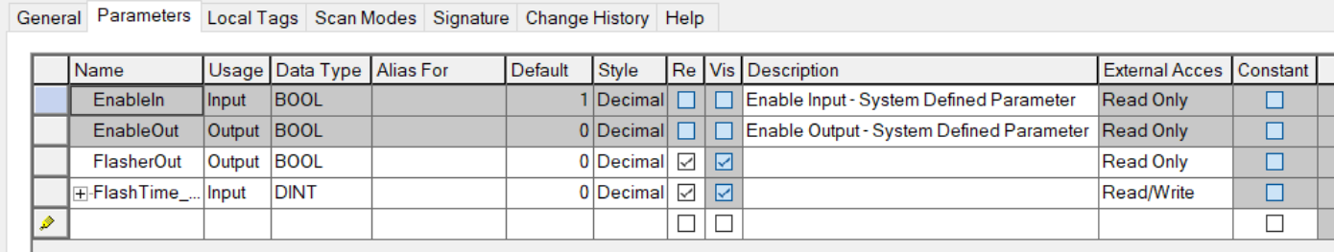

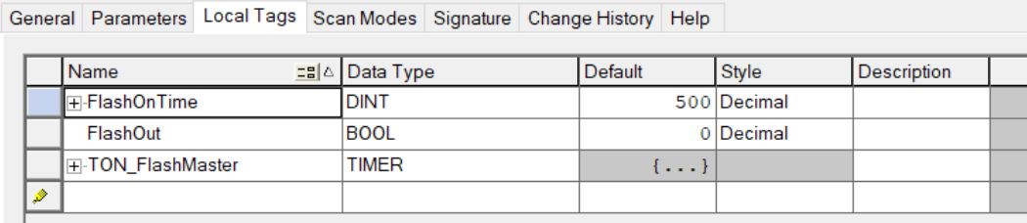
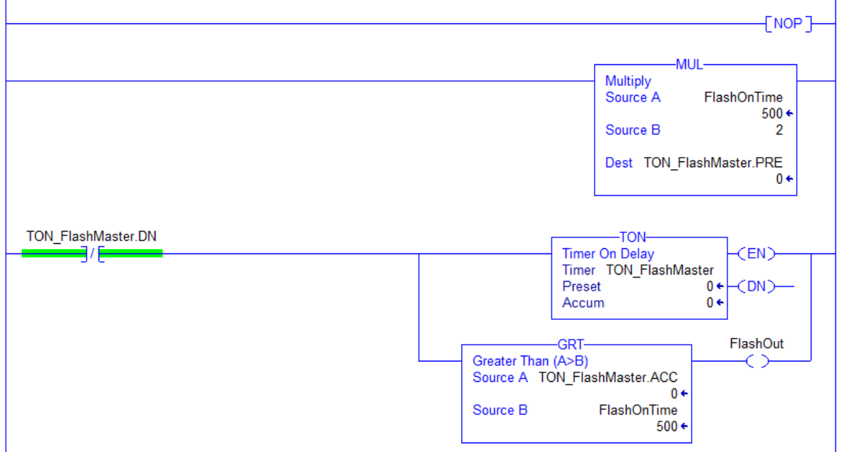

Portions of Recipe System
Main
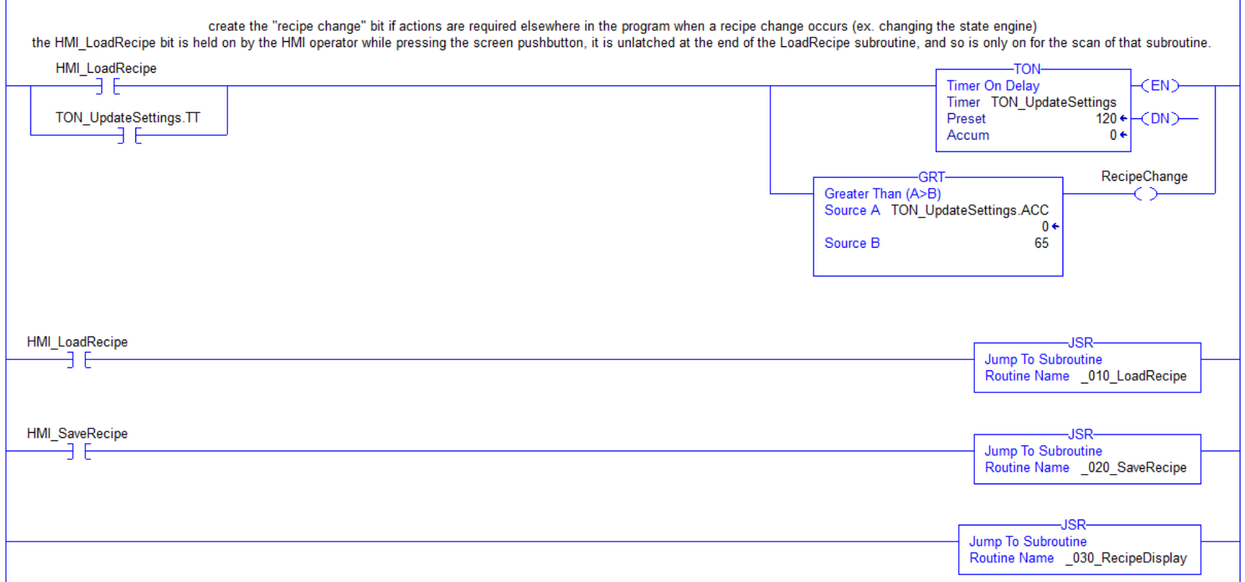

Load
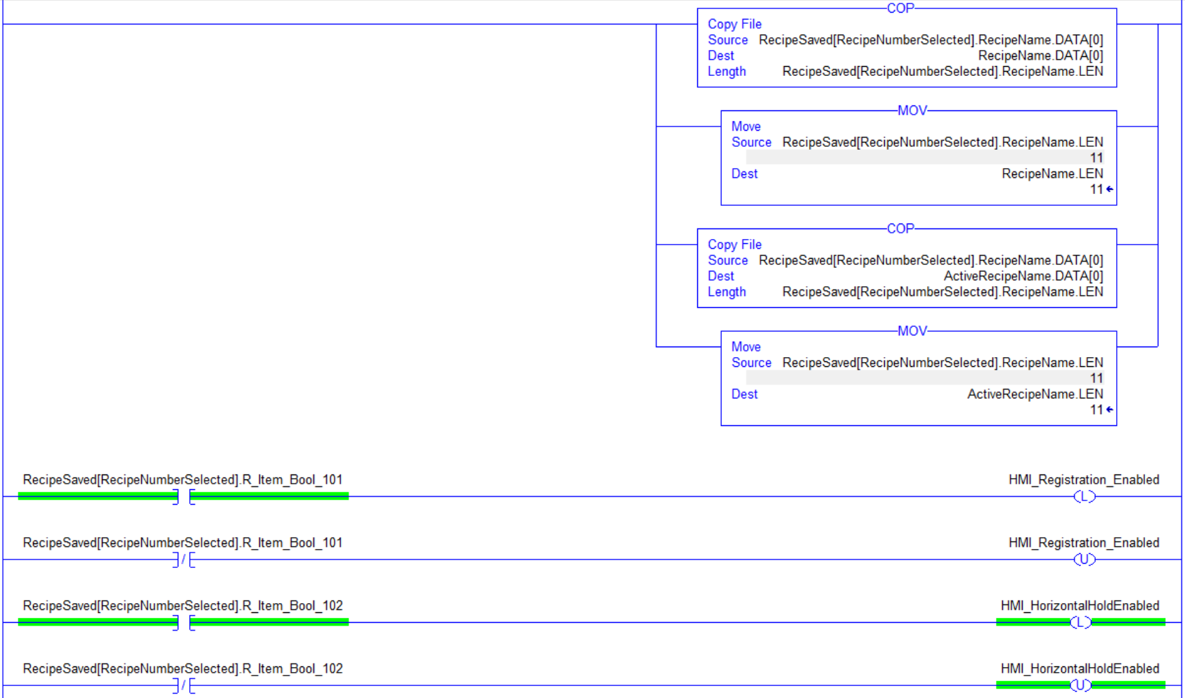
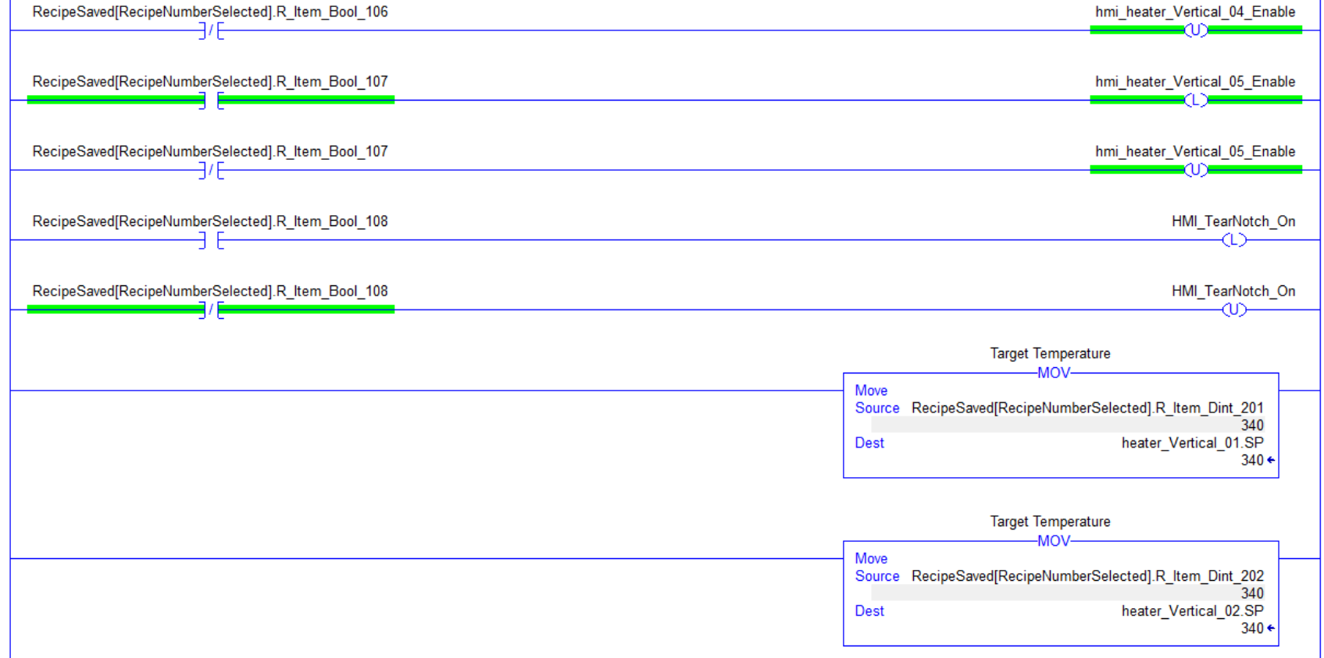

Recipe Save

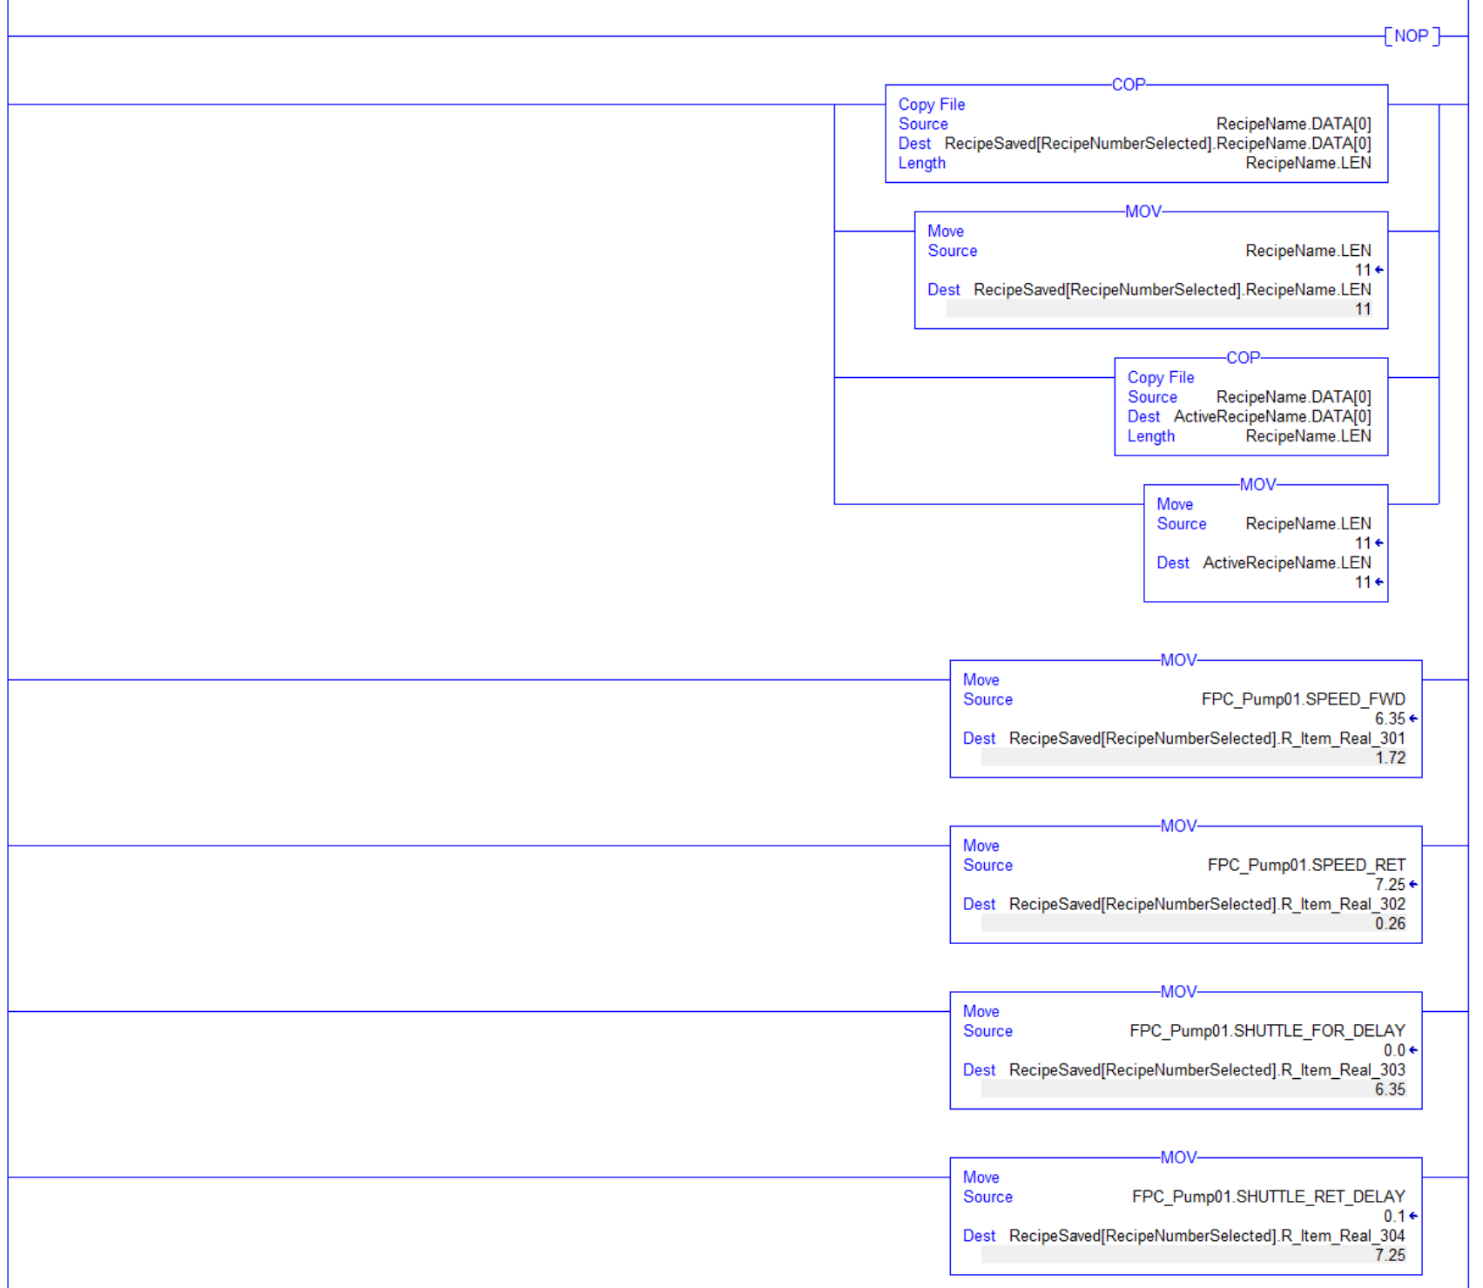

Recipe Display

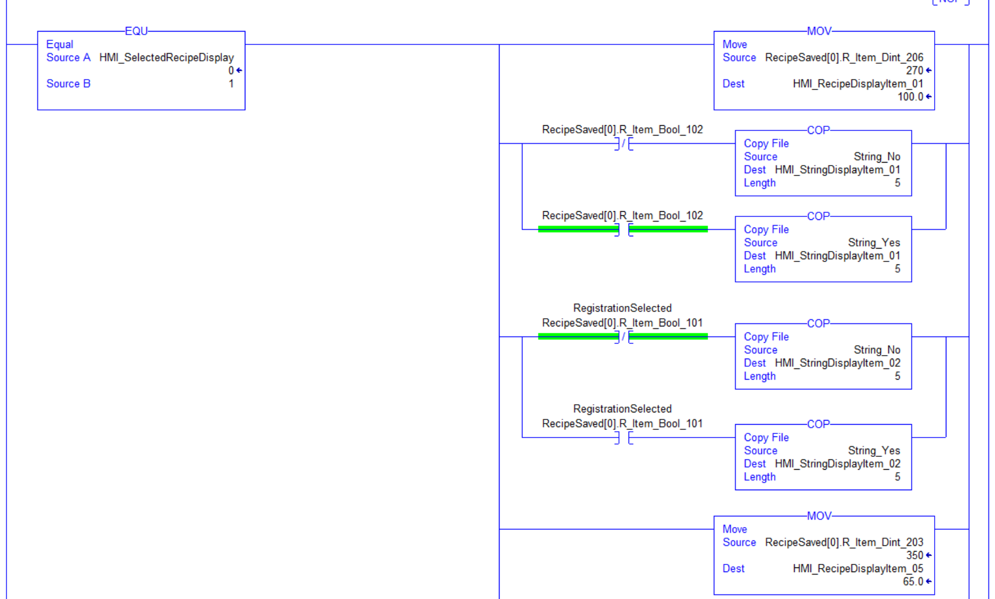
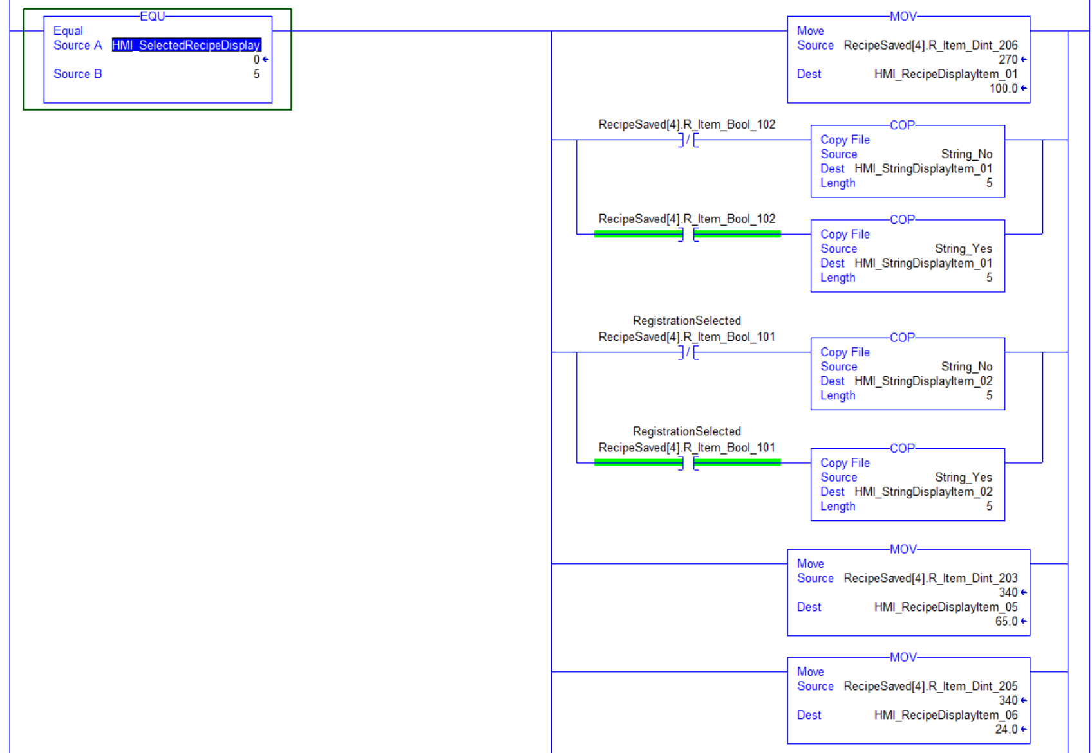

Latch on single scan with external analog input (cam).

